1.1 INRODUCTUON

* Event create opportunities for people to connect with an area. spend time together. Celebrate and experience the diversity of cultures and foster creativity and innovation. They allow a community to came alive and provide an opportunity for a destination to showcase its tourism experience and increase economic activity. Events contribute significantly to community building, lifestyle and leisure enhancement. cultural development, tourisms promotions and increased visitation. volunteer participation. fundraising and economic development. Most importantly. Events create a sense of fun and vibrancy, resulting in a strong sense of community connectivity, pride and a sense of p

2. EMPATHY MAP:

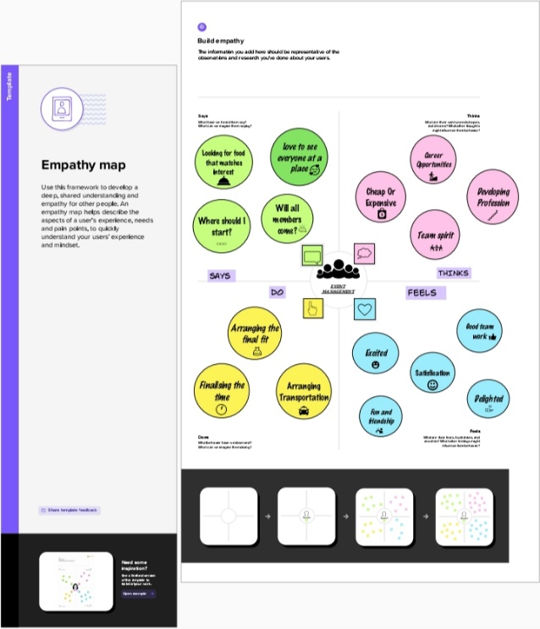  
2.2 IDEATION AND BRAISTORMING MAP

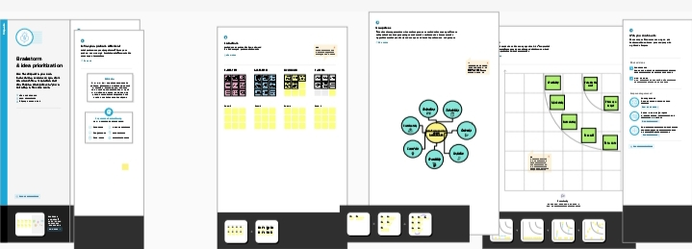

3. RESULT

3.1 DATA MODEL

|  |  |  |
| --- | --- | --- |
| OBJECT NAME | Fields in the Object | |
| OBJ1 | Field label | data type |
| Salesforce objects are database that permit you to store data that is | Custom object field& relationship Master detail relationships |
| OBJ2 | Field label | data type |
| Field in every custom object in the field created dt the time of the creation of object | The relationship field is required on all sharing of a details record use the deletes the master record |

4. ACTIVITY and SCREENSHOT

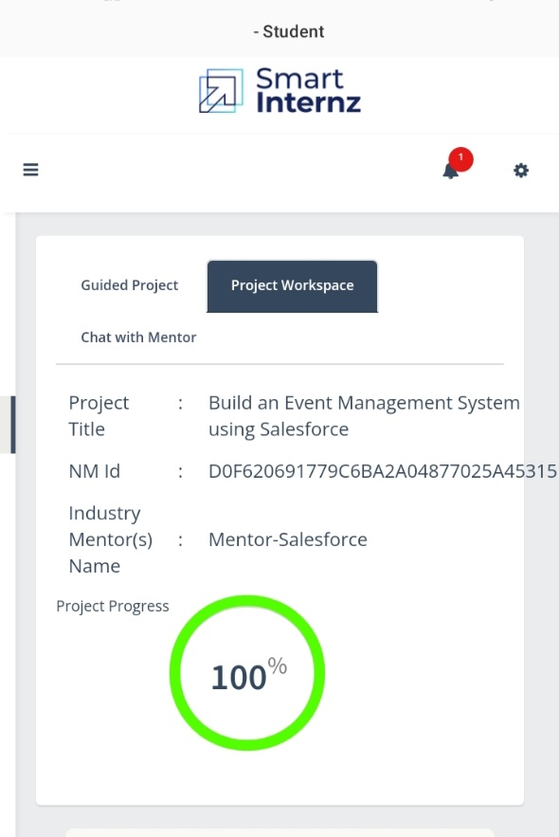

4.Trailhead profile public URL

Team leader : trailblazer. me/id/ksumathi3

Team Member 1: trailblazer.me/id/jayag2206

Team member 2: trailblazer.me/id/gayathrik22

Team member 3: trailblazer.me /id/hariv115

Project report Template

5. ADVANTAGES& DISAVANTAGE

* Opportunities for creativity…
* Ability to work on different events…..
* Chance to work with diverse clients…
* Collaborative work environment…
* High protectional for job growth…
* Few educational requirements.…..
* Unconventional work hours..
* Time away from family and friends…

6. APPLICATION

* An applicant build event management
* Simplify events experience
* Enhances attendees’ Interest
* Make connections
* Analyze Data

7. CONCLUSION:

* The event report will contain things like
* Scathing and light arrangements
* Promotional materials used
* Bluepoint of the whole venue
* Program and food menu
* Contact details of sponsors ,partners, clients,(for whom the event is organized)

8. FUTURE SCOPE

* TRENDS OF EVENT MSNAGEMENT
* Using Insert net of things( IOT Technology)
* Celebrations and occasions are an important life.
* One or other day through every corner of the globe
* Some can be wedding, exhibitions, concerts, fairs, parties etc…...
* So have you ever appointed any events management company for your family or business events…
* If yes, then you might be having a good idea about how event companies works and if to no, then no worries just get back to you seat and go through this whole article...